Eesti kurtide koondis Toronto MM-il
Estonian team in Toronto Deaf Athletics Championships 2012
 
Link ametlikule kodulehele: www.2012wdac.org

EMILIJA MANNINEN  Age 31, Women, ESTONIA  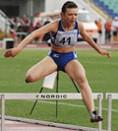 | - 100m – 12,49  - 200m – 26,05  - 400 m Hurdles 62,94  - Home Jyväskyla, FIN  - Achievements Deaflympics 2009 - silver 400 meters hurdles.  - Deaflympics 2001 - Bronze 400 meters hurdles and 4x400 meters relay race  - Deaf World Record Holder - 400m hurdles with 62.94 sec (2009)  - Occupation - Housewife Parental Leave  - Contact:emilija.manninen@gmail.com
MARJA-LIISA LANDAR  Age 22, Women, ESTONIA    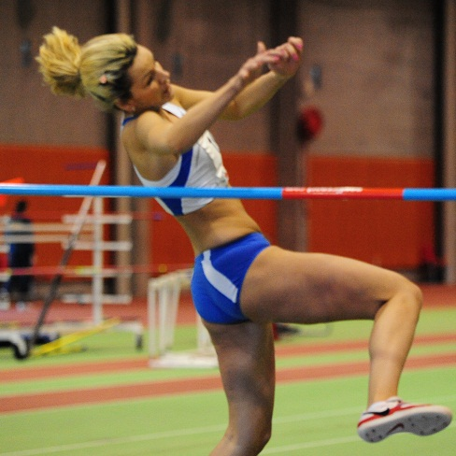 | - High Jump – 1.60  - Long Jump – 5.05  - Home Tallinn /EST  - Achievements Deaflympics 2009 - bronze 4x100 m relay race and high jump 4th place.  - World Deaf Athletics Championships 2008 - bronze 4x100 meters relay race and high jump 4th place  - Occupation: Vunder AS, Lao pickers  - Contact: liisalandar@live.com
KAIRIT OLENKO  Age 26, Women, ESTONIA  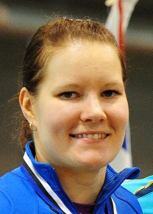  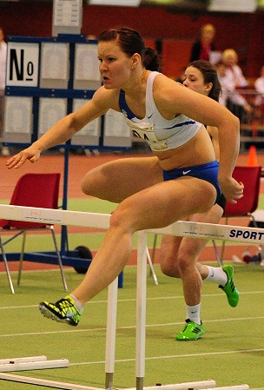 | - 100m hurdles – 14,39 sec  - Javelin – 45,85  - Heptathlon – 5062  - Home Tallinn /EST  - Achievements: Deaflympics 2009 - 3 gold in 100 meters hurdles, Javelin throw and heptathlon,  - 2005 Deaflympics - 2 gold, 100m hurdles and 7 to race, a bronze javelin throw,  - Deaflympics 2001- silver 100m tхkkejooksus,  - World Deaf Athletics Championships 2008 - 2 gold 100 meters hurdles and Heptathlon, and silver javelin throw  - Deaf world record holder - 100m hurdles with 14.39 seconds. (2009) and Heptathlon 5062 (2008)  - Educational institutions: TTU student  - Contact: kolenko85@gmail.com
JORGEN LIIV  Age 22, Men, ESTONIA  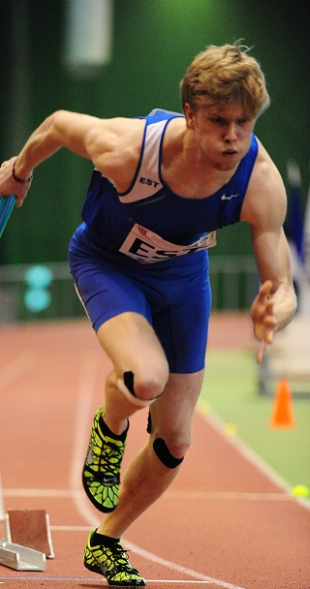 | - 100 m – 11,52  - 200m – 23,59  - Home Tallinn / EST  - Educational institutions: TTU student  - Contact: joke_liiv_10@hotmail.com
MATVIJENKO SERGEI TÕENISMA TIMO
Team representative Coach


